1. For each of these code snippets, how many times will the print statement execute?

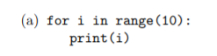

10

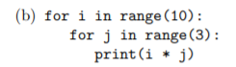

30

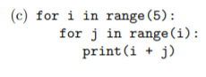

15



9



Infinite

1. What will each of these code snippets print?



\*

\*

\*

\*

\*



\*\*\*\*\*



\*

\*\*

\*\*\*

\*\*\*\*



\*

\*\*

\*\*\*

\*\*\*\*

\*\*\*\*\*



\*

\*

\*

\*

\*